**APPLICATION PACKAGING**

**What is application packaging :**

Application package is the process of preparing software for deployment by building all necessary files, configuration, and dependencies into a standardized package.

This process streamlines software distribution, reduces compatibility issues and ensure consistent installations. The step typically involves application discovery, packaging, user acceptance testing and deployment.

**Steps in Application Packaging:**

1. Application Discovery - This involves understanding the software, its dependencies, and the environment where it will be deployed.
2. Application packaging - The actual creation of the package, which includes all necessary files, setting, and scripts.
3. UAT(User Acceptance Testing) – This step verifies that the packaged application functions correctly in the target environment and meet the user’s requirements.
4. Application Deployment – The process of installing and configuring the packaged application on the end-user device.

Application packaging helps organizations in need of a way to make the burden off their IT support teams while providing an improved end-user experience.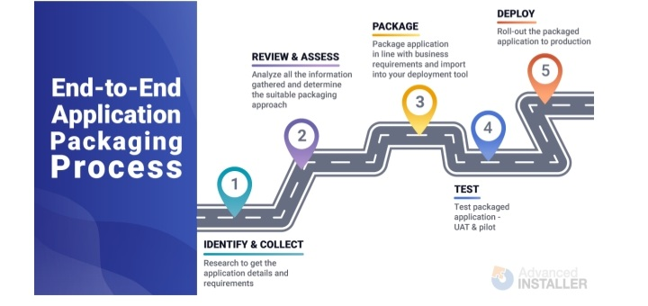

### What is an MSIX File?

MSIX is a packaging format developed by Microsoft for the distribution of applications. It is a container that houses all the components necessary for an application to run, including its files, resources, and configuration settings.

#### Using the Microsoft Store

Some MSIX applications are distributed through the Microsoft Store. Installing via the Store can simplify the process and provide seamless updates. To install an application from the Microsoft Store:

1. **Open Microsoft Store**:
   * Click on the **Start** button and search for **Microsoft Store**.
2. **Search for Your Application**:
   * In the Store, use the search bar at the top to find the desired application.
3. **Install**:
   * Click the application from the search results and hit the **Install** button. The application will download and install automatically.
4. **Launch the Application**:
   * Once installed, you can launch it directly from the Store or find it in your Start menu.

#### Installing via File Explorer

This is the most straightforward way to install an MSIX file. Follow these steps:

1. **Locate the MSIX File**:
   * Open **File Explorer** (Windows + E) and navigate to the location where your MSIX file is saved.
2. **Run the MSIX Installer**:
   * Double-click the MSIX file. This action should trigger the Windows Package Manager, which will display details about the application, including its name and publisher.
3. **Start Installation**:
   * Click on the **Install** button in the installer window. You might be prompted with a User Account Control (UAC) dialog asking for permission; click **Yes** to proceed.
4. **Wait for Installation**:
   * The installation process will take a few moments. Once completed, you will receive a confirmation message indicating that the application has been installed successfully.
5. **Access the Application**:
   * You can find your newly installed application by searching for it in the Start menu.

* **What is MSI’s – A message signaled Interrupt is a write from the device to a special address which causes an interrupt to be received by the CPU.**

**Difference between User, Admin, system context**

In MSI, the context refers to the level of access a process or component has within the windows operating system.

USER CONTEXT:

Run under the currently logged-in user’s credentials and within their user profile**. Can access files and setting specific to the user profile, but typically doesn’t have full system-wide access.**  It is best for user specific applications, customizations ,and tasks that don’t require system-wide changes.

SYSTEM CONTEXT:

**It has access to all files and system resources, including those outside the user’s profile.**

ADMIN CONTEXT:

**These Installations requires to the user to have admin privileges to run the MSI and the perform the necessary system change.**

* **User context: limited access to the user profile.**
* **System context: full system-wide access.**
* **Admin context: requires admin privileges for system-wide changes.**